

**Capstone Project Report**

**Report 2 – Project Management Plan**

– Ho Chi Minh City, 01/2021 –

**Table of Contents**

I. Project Report 4

1. Status Report 4

2. Team Involvements 4

3. Issues/Suggestions 4

II. Project Management Plan 5

1. Overview 5

1.1 WBS & Estimation 5

1.2 Project Objectives 8

1.3 Project Risks 9

2. Management Approach 10

2.1 Project Process 10

2.2 Quality Management 11

2.3 Training Plan 11

3. Master Schedule 11

4. Project Organization 12

4.1 Team & Structures 12

4.2 Roles & Responsibilities 12

5. Project Communication 13

5.1 Communication Plan 13

5.2 External Interface 13

6. Configuration Management 14

6.1 Tools & Infrastructures 14

6.2 Document Management 14

6.3 Source Code Management 14

**List Tables**

Table 1. Work Breakdown Structure & Estimation 7

Table 2. Project Objectives 9

Table 3. Project Risks 10

Table 4. Training Plan 11

Table 5. Master Schedule 12

Table 6. Roles & Responsibilities 13

Table 7. Communication Plan 13

Table 8. FU Contacts 13

Table 9. Customer Contacts 14

Table 10. Tools & Infrastructures 14

**List Figures**

Figure 1. Scrum Framework 10

Figure 2. Team & Structures 12

# I. Project Report

## 1. Status Report

|  |  |  |  |
| --- | --- | --- | --- |
| **#** | **Work Item** | **Status** | **Notes (Work Item in Details)** |
| 1 |  | Pending |  |
| 2 |  | In Progress |  |
| 3 |  | Completed |  |

## 2. Team Involvements

|  |  |  |  |
| --- | --- | --- | --- |
| **#** | **Task** | **Member** | **Notes (Task Details, etc.)** |
| 1 |  | HaPTN |  |
| 2 |  | NguyenLG |  |
| 3 |  | GiaNH |  |
| 4 |  | ~~PhuVT~~ | Dropped since January 28th, 2021 |

## 3. Issues/Suggestions

|  |  |  |  |
| --- | --- | --- | --- |
| **#** | **Issue** | **Status** | **Notes (Solution, Suggestion, etc.)** |
| 1 |  | Pending |  |
| 2 |  | In Progress |  |
| 3 |  | Completed |  |

# II. Project Management Plan

## 1. Overview

### 1.1 WBS & Estimation

|  |  |  |  |
| --- | --- | --- | --- |
| **#** | **WBS Item** | **Complexity** | **Est. Effort**  **(man-days)** |
| ***1*** | ***Initiating*** |  | ***14*** |
| 1.1 | Meet customers at Viet Anh School (Major Education) | Simple | 1 |
| 1.2 | Gain requirements | Medium | 3 |
| 1.3 | Write “Current System Description” | Medium | 4 |
| 1.4 | Confirm “Current System Description” with customers | Simple | 1 |
| 1.5 | Write Report 1 (Introduction) | Medium | 4 |
| 1.6 | Collect stakeholders’ contact information | Simple | 1 |
| ***2*** | ***Planning*** |  | ***17*** |
| 2.1 | Discuss project scope with development team | Simple | 3 |
| 2.2 | Estimate time to finish the project | Simple | 1 |
| 2.3 | Discuss project’s limitations and risks | Simple | 2 |
| 2.4 | Discuss model to use for project management | Simple | 2 |
| 2.5 | Create project plan & work breakdown structure (WBS) | Simple | 3 |
| 2.6 | Assign roles in this project for each team member | Medium | 1 |
| 2.7 | Write Report 2 (Project Management) | Medium | 5 |
| ***3*** | ***Executing*** |  | ***294*** |
| **3.1** | **Analysis** |  | **41** |
| 3.1.1 | Analyse users’ requirements:   * Identify stakeholders * Identify user roles in this system * Identify needs and activities of each role | Complex | 9 |
| 3.1.2 | Analyse materials that Major provided   * Analyse Major current working process (7 steps) * Analyse Excel files (including sample data of target schools, assignment, daily reports,…) | Medium | 4 |
| 3.1.3 | Research business definitions | Simple | 2 |
| 3.1.4 | Use free trial of CRM applications (CRMViet, EasyEdu,…) | Simple | 3 |
| 3.1.5 | Create Use case Diagram | Complex | 8 |
| 3.1.6 | Write Report 3 (Software Requirement Specification – SRS) | Complex | 15 |
| **3.2** | **Designing** |  | **34** |
| 3.2.1 | Create Entity Relationship Diagram (ERD) | Medium | 6 |
| 3.2.2 | Create Database Diagram | Simple | 3 |
| 3.2.3 | Create Class Diagram | Medium | 4 |
| 3.2.4 | Create Architecture Diagram | Medium | 3 |
| 3.2.5 | Standardize provided Excel files | Simple | 3 |
| 3.2.6 | Write Report 4 (Software Design Document – SDD) | Complex | 15 |
| **3.3** | **Prototyping** |  | **27** |
| 3.3.1 | Draw draft major screens on paper | Simple | 6 |
| 3.3.2 | Create prototype for role Admin | Simple | 3 |
| 3.3.3 | Create prototype for role Salesman | Medium | 9 |
| 3.3.4 | Create prototype for role Sales Supervisor | Medium | 6 |
| 3.3.5 | Create prototype for role Sales Manager | Medium | 3 |
| **3.4** | **Implementing** |  | **153** |
| 3.4.1 | Install coding environment (Eclipse, Visual Studio Code) | Simple | 2 |
| 3.4.2 | Identify coding conventions (Front-end & Back-end) | Medium | 2 |
| 3.4.3 | Implement “Admin” module – Iteration 1 |  |  |
| 3.4.3.1 | Update SRS and SDD (Iteration 1) | Medium | 9 |
| 3.4.3.2 | Create test plan and test cases (Iteration 1) | Medium | 6 |
| 3.4.3.3 | Code and perform unit test (Iteration 1) | Complex | 9 |
| 3.4.3.4 | Deploy package 1 | Simple | 3 |
| 3.4.4 | Implement “Salesman” module – Iteration 2 |  |  |
| 3.4.4.1 | Update SRS and SDD (Iteration 2) | Medium | 12 |
| 3.4.4.2 | Create test plan and test cases (Iteration 2) | Medium | 6 |
| 3.4.4.3 | Code and perform unit test (Iteration 2) | Complex | 15 |
| 3.4.4.4 | Execute integration test and system test (Iteration 2) | Medium | 6 |
| 3.4.4.5 | Deploy package 2 | Simple | 1 |
| 3.4.5 | Implement “Sales Supervisor” module – Iteration 3 |  |  |
| 3.4.5.1 | Update SRS and SDD (Iteration 3) | Medium | 12 |
| 3.4.5.2 | Create test plan and test cases (Iteration 3) | Medium | 6 |
| 3.4.5.3 | Code and perform unit test (Iteration 3) | Complex | 15 |
| 3.4.5.4 | Execute integration test and system test (Iteration 3) | Medium | 9 |
| 3.4.5.5 | Deploy package 3 | Simple | 1 |
| 3.4.6 | Implement “Sales Manager” module – Iteration 4 |  |  |
| 3.4.6.1 | Update SRS and SDD (Iteration 4) | Medium | 12 |
| 3.4.6.2 | Create test plan and test cases (Iteration 4) | Medium | 6 |
| 3.4.6.3 | Code and perform unit test (Iteration 4) | Complex | 9 |
| 3.4.6.4 | Execute integration test and system test (Iteration 4) | Medium | 9 |
| 3.4.6.5 | Deploy package 4 (product version Alpha) | Simple | 3 |
| **3.5** | **Testing** |  | **30** |
| 3.5.1 | Fix bugs and retest | Medium | 12 |
| 3.5.2 | Get feedback from customers after acceptance test | Medium | 8 |
| 3.5.3 | Deploy full package (product version Beta) | Simple | 4 |
| 3.5.4 | Write Report 5 (Testing) | Medium | 6 |
| **3.6** | **Support** |  | **9** |
| 3.6.1 | Write Report 6 (User Guides) | Medium | 6 |
| 3.6.2 | Train customers (end-users) how to use this application | Simple | 3 |
| ***4*** | ***Monitoring and Controlling*** |  | ***9*** |
| 4.1 | Evaluate project’s code quality | Complex | Cannot estimate due to SCRUM model |
| 4.2 | Refractor/Optimize code (optional) | Complex |
| 4.3 | Tracking project’s progress, scope and risks | Medium |
| 4.4 | Write Report 7 (Final Project Report) | Complex | 9 |
| ***5*** | ***Closing*** |  | ***18*** |
| 5.1 | Create final presentation | Simple | 6 |
| 5.2 | Practice Thesis presentation | Medium | 9 |
| 5.3 | Present at Capstone Project Defense | Complex | 3 |
| ***Total Estimated Effort (man-days)*** | | | ***352*** |

Table 1. Work Breakdown Structure & Estimation

### 1.2 Project Objectives

To create an utility, practical and friendly sales management application for Sales Department of Major Education.

|  |  |  |  |  |
| --- | --- | --- | --- | --- |
| **#** | **Quality Stage** | **No. of Defects** | **% of Defect** | **Notes** |
| 1 | Initiating | 2 | 8.7% | * Gain sufficient and useful information for requirement analysis in the next stage. * All team members must understand clearly customer’s situation and demands. |
| 2 | Planning | 1 | 4.3% | Project plan must be attainable, time-bound and specific. |
| 3 | Analysis | 4 | 17.4% | Confirm SRS (functional requirements, non-functional requirements, business rules) with the customers before moving to “Implementing” stage. |
| 4 | Designing | 4 | 17.4% | * Design Use Cases Diagram, ERD and Database based on result of stage 3 (Analysis). * Review carefully with the Instructor before moving to the next stages. |
| 5 | Prototyping | 3 | 13.2% | Design and confirm with customers all screens of all roles before move to “Implementing” stage. |
| 6 | Implementing | 4 | 17.4% | * Strictly follow the general coding convention. * All team members need to update code regularly. |
| 7 | Testing | 2 | 8.7% | * Each developer applys unit test before merge code with each other. * Both Front-end code and Back-end code need to be tested carefully before deploying to the Server. * Have Acceptance test (-test) in the customet-side, in real business environment. |
| 8 | Support | 1 | 4.3% | Project team needs to provide User Guide documents, and also spend time in real business environment to support to the customers at the beginning of the deployment. |
| 9 | Monitoring & Controlling | 1 | 4.3% | * Not only Team Leader needs to track the progress of other team members. * Using version control to keep track of the changes in stages “Designing”, “Prototyping” and “Implementing”. * Applying SCRUM model. |
| 10 | Closing | 1 | 4.3% | All team members need to join slide designing and prepare thoroughly for the final presentation. |
| ***Total*** | | ***23*** | ***100%*** |  |

Table 2. Project Objectives

### 1.3 Project Risks

|  |  |  |  |  |
| --- | --- | --- | --- | --- |
| **#** | **Risk Description** | **Impact** | **Possibility** | **Response Plans** |
| **I** | **Requirement risks** | | | |
| 1 | Development team misunderstands or unclears customer requirements | High | High | Meet customers regularly to confirm our thoughts or do not hesitate to ask customers via Zalo group chat. |
| 2 | Customers do not clear about their requirements | High | Medium | Create prototypes or suggest our solutions to customers and confirm with them what features they want to use. |
| 3 | Unexpected scope change | Medium | Low | If new feature is justifiable and time remaining is enough, development team will implement that feature.  If not, team need to deal with customers to implement that feature in the next version. |
| **II** | **Techical risks** | | | |
| 4 | Lack of technical knowledge or poor coding skills | High | Medium | * Enhance self-research. * Exchange knowledge with other team members or other teams. |
| 5 | Poor code quality | Medium | Medium | Strictly follow code convention, carry out acceptance test to ensure quality source code. |
| **III** | **Human risks** | | | |
| 6 | Restricted in direct meeting and communication due to Covid-19 | High | High | * Team can use online meeting platforms (Google Meet, Zoom,…) or send resources via email. * Team can deploy live demo on Ngrok for customers using. |
| 7 | Conflicts between team members | High | High | Team need a meeting, all members share uncomfortable things. |
| 8 | Over deadline | High | High | * Each member has to report their working progress daily. * Team members need to support each other to finish tasks in time. |
| 9 | Lack of real experiences | Low | High | Ask instructor or customer Exchange knowledge with other team members or other teams. |

Table 3. Project Risks

## 2. Management Approach

The project management model our team chose to manage and implement in this project is Agile methodology, for more specific, is Scrum framework.

### 2.1 Project Process

We chose Scrum framework because of the following reasons:

* As we are making real product for a real company, we need to satisfy the customers first by early deliverables.
* Scrum requires regular meeting and communication, so development team will closely follow user’s requirements, reduce deviation.
* Scrum welcome changes, even during the developing process.
* Scrum allows us to divide work into small sprints, which will deliver module package each sprint, so we can easily manage bugs, fix bugs faster and reduce risks.

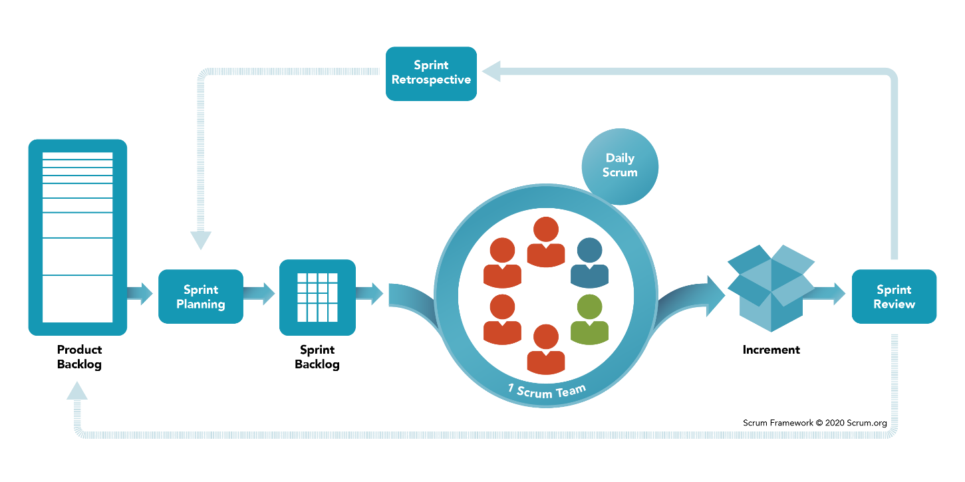

Figure 1. Scrum Framework

*Reference:* [*https://www.scrum.org/resources/what-is-scrum*](https://www.scrum.org/resources/what-is-scrum)

Product backlog and Sprint backlog can be seen at *http://bit.ly/salesmgt-backlog*.

### 2.2 Quality Management

To enhance the quality, the team have to:

* Follow all code conventions and ensure clean code.
* Refer to and study similar working applications in the market.
* Ensure all team members clearly understand user requirements and prototype.

### 2.3 Training Plan

|  |  |  |  |
| --- | --- | --- | --- |
| Training Area | Participants | When, Duration | Waiver Criteria |
| Java Spring Boot | All team members | Week 3 | Mandatory |
| HTML, CSS, Javascript (ES6) | All team members | Week 1 | Mandatory |
| SCSS | HaPTN, GiaNH | Week 1 | Optional |
| ReactJS | All team members | Week 3 | Mandatory |
| UML 2.0 conventions | All team members | Week 2 | Mandatory |
| Git, Github | All team members | Week 1 | Mandatory |

Table 4. Training Plan

## 3. Master Schedule

|  |  |  |  |
| --- | --- | --- | --- |
| **#** | **Deliverable** | **Due Date** | **Deliverable Scope** |
| 1 | Project Introduction (Report 1) | Week 2 |  |
| 2 | Project Plan (Report 2) | Week 2 | Work Breakdown Structure (WBS) |
| 3 | SRS (Report 3) | Week 4 | Use case Diagram and Specification, non functional requirements, screen flow and description |
| 4 | Design (Report 4) | Week 6 | Architecture Diagram, Detailed Design, ERD, Database Diagram, Prototypes |
| 5 | Code Package 1: module “Admin” (Front-end) | Week 8 | Codes & Unit test cases |
| 6 | Code Package 2: module “Salesman” (Front-end) | Week 10 | Codes & Unit test, System test cases |
| 7 | Code Package 3: module “Sales Supervisor”  (Front-end) | Week 12 | Codes & Unit test, System test test cases |
| 8 | Code Package 4: module “Sales Manager”  (Front-end) | Week 12 | Codes & Unit test, System test test cases |
| 9 | Code Package 1  (Back-end) | Week 8 | Codes & Unit test cases |
| 10 | Code Package 2  (Back-end) | Week 10 | Codes & Unit test, System test test cases |
| 11 | UAT Package | Week 14 | Code, System test reports |
| 12 | Final Package | Week 15 | Final codes & documents, User guides |

Table 5. Master Schedule

## 4. Project Organization

### 4.1 Team & Structures

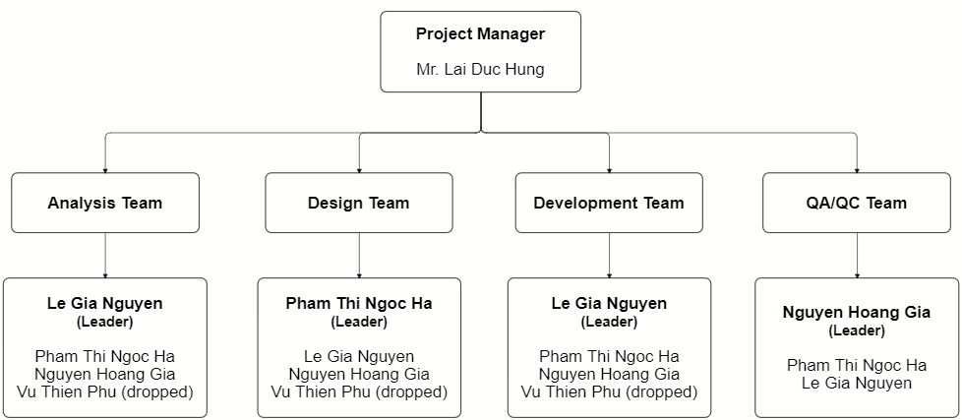

Figure 2. Team & Structures

### 4.2 Roles & Responsibilities

|  |  |
| --- | --- |
| **Role** | **Responsibility** |
| Project Manager | * Be a bridge between Major Education and FPTU development team in the initial stage of the project. * Give guidance, review deliverables during project time. |
| Analysis Leader | * Communicate with the customers to get requirements. * Analyse customer’s requirements and business then explain to team members. * Generate use cases and diagrams in Software Design Description (SDD). * Review and adjust project’s documents made by analysis members. |
| Analysis Member | * Communicate with customers to get requirements. * Analyse customer’s requirements and business. * Draw software diagrams (use cases diagram, ERD,…) and write documents (SRS, SDD). |
| Design Leader | * Design prototypes for website layouts. * Assign tasks for team members. |
| Design Member | * Design prototypes for tasks assigned by the Design Leader. * Review draft prototypes of Design Leader. * Review prototypes of each other. |
| Technical Leader | * Study and decide architecture and technologies using in the project. * Assign tasks for development team members. * Track the work progress of the project. * Review member's code and fix errors. |
| Developer | * Implement code for tasks assigned by the Technical Leader. * Implement unit test. |
| Test Leader | * Write test cases and test plan for the project. * Assign tasks for team members. * Review test results of team members and make test strategy. * Implement the system test. * Collect and analyse customer’s comments at phase UAT. |
| Test Member | Write test cases and test modules as tasks assigned by the Test Leader. |

Table 6. Roles & Responsibilities

## 5. Project Communication

### 5.1 Communication Plan

|  |  |  |  |  |
| --- | --- | --- | --- | --- |
| **Communication Item** | **Who/ Target** | **Purpose** | **When, Frequency** | **Type, Tool, Method(s)** |
| First meeting | Project supervisor, Project team, Major team (customers) | Introduce the project | Once | Meeting |
| Weekly meeting | Project supervisor, Project team | Review project status | Weekly | Meeting |
| Meeting minute reports | Project supervisor, Project team | Inform supervisor and team members about weekly meeting contents | Weekly | Document file  Submit via email |

Table 7. Communication Plan

### 5.2 External Interface

#### a. FU Contacts

|  |  |  |  |
| --- | --- | --- | --- |
| Function | Contact Person  (name, position) | Contact address  (email, telephone) | Responsibility |
| Supervisor | **Lai Duc Hung**  Instructor | [HungLD5@fe.edu.vn](mailto:HungLD5@fe.edu.vn)  0976.710.580 | - Provide document templates. - Give instruction to project team. - Review deliverables. - Supervise project status. |

Table 8. FU Contacts

#### b. Customer Contacts

|  |  |  |  |
| --- | --- | --- | --- |
| Function | Contact Person  (name, position) | Contact address  (email, telephone) | Responsibility |
| Customer Representor | **Pham Duy Tien** Sales Supervisor | [duytien@truongvietanh.com](mailto:duytien@truongvietanh.com)  0963.281.235 | - Give and describe requirements.  - Review deliverables of the development team. |
| Coordinator | **Tran Thi Xuan Tuyen**  Account Manager | [xuantuyen@truongvietanh.com](mailto:xuantuyen@truongvietanh.com)  0938.137.949 | Introduce project and related person in charge of this project |
| Supporter | **Le Quy Mai Huyen**  Vice president | huyen@truongvietanh.com  0984.388.988 | Support to connect between Major team and development team. |

Table 9. Customer Contacts

## 6. Configuration Management

### 6.1 Tools & Infrastructures

|  |  |
| --- | --- |
| **Programming languages** | Java (Java EE 11), Javascript (ES6) |
| **Framework** | Spring Boot |
| **Library** | ReactJS, Syncfusion |
| **API** | RESTful API, Postman, Swagger |
| **DBMS** | MySQL |
| **IDEs/Editors** | Eclipse, Visual Studio Code |
| **UML tools** | StarUML, LucidChart, draw.io, Cacoo |
| **Version Control** | git (GitHub) |
| **Deployment server** | Amazon Web Services (EC2, RDS) |
| **Cloud Services** | Firebase Storage (store images) Firebase Realtime Database (store notifications) |
| **Project management tool** | Jira |

Table 10. Tools & Infrastructures

### 6.2 Document Management

We create a shared GitHub account only used only for this project, all team members can access to this account.

In this account, we create a repository for storing all materials related to documents, including 7 reports, requirements analysis, Major’s files, UML diagrams of SDD and weekly meeting minutes.

Link: <https://github.com/salesmgt/documentation>.

### 6.3 Source Code Management

In the shared GitHub account mentioned in part 6.2, we create one repository for prototype, one for front-end codes and one for back-end codes.

Link: <https://github.com/salesmgt/prototype>.